Assignment Submission Report
Name:Courtney Swift
Course / Cohort: 68
Assignment: 1
GitHub Repository Link: https://github.com/courtney-swift/Restaurant.git
Evidence of Functionality

Frontend/UI
Attach 3 screenshots only:
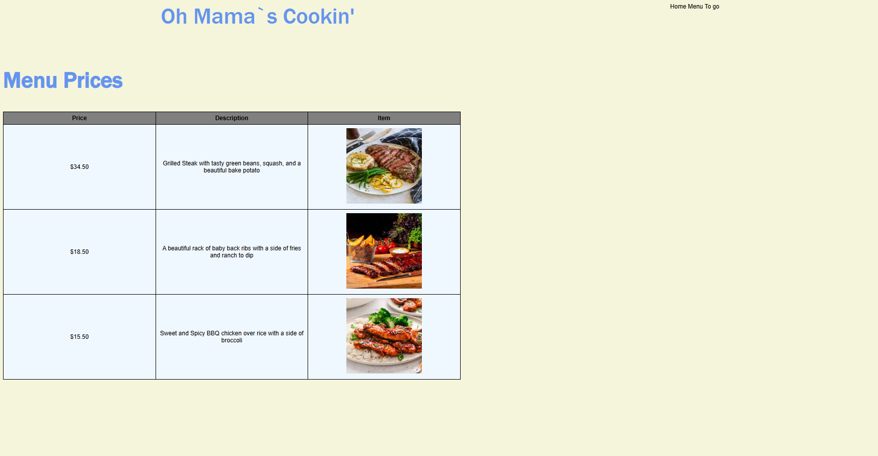

Backend/Logic

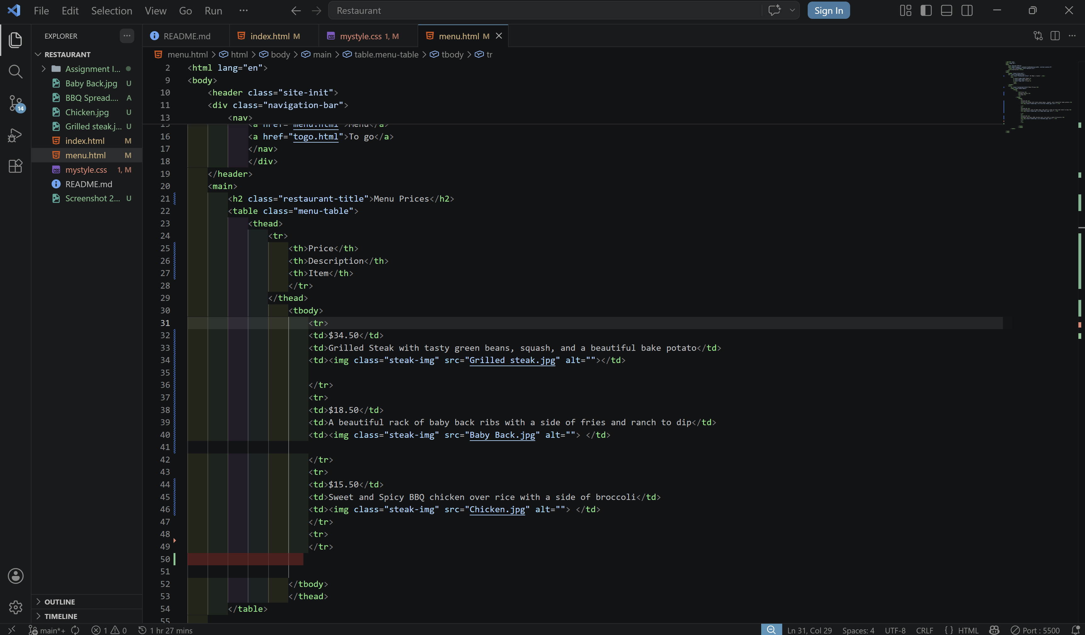
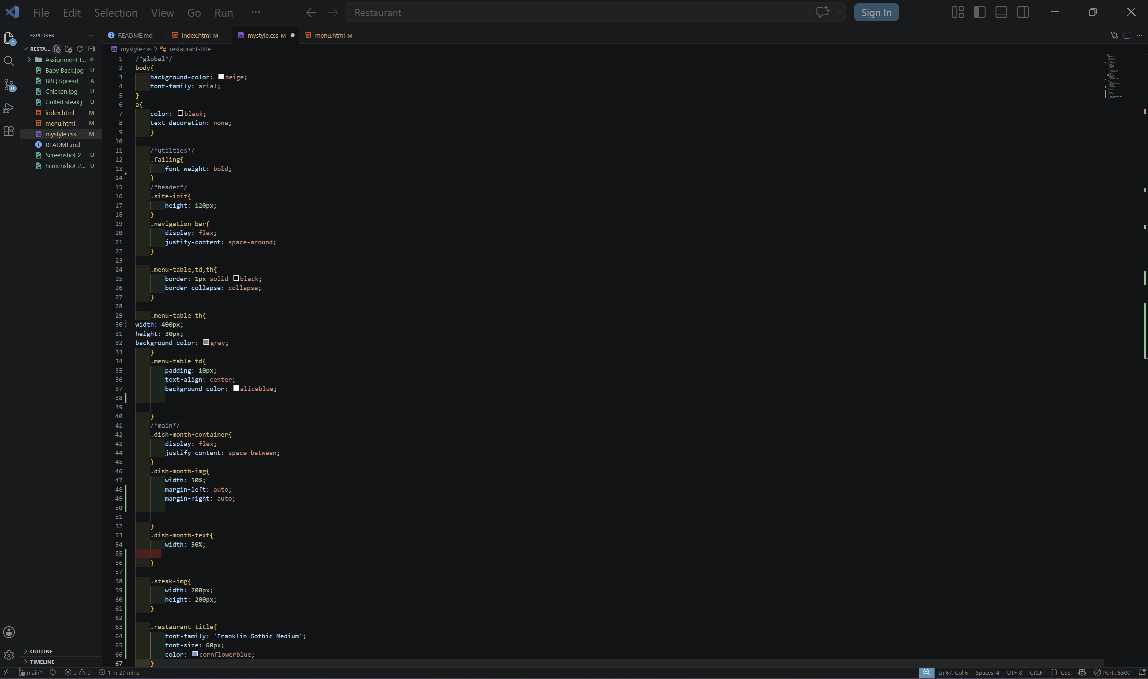

AI Disclosure (Required) – Highlight the one that applies
- I did not use AI
- I used AI for help
- AI generated parts of my code

